**LAB – 4**

Name: Amit Kumar Sahu

Reg. No: 18mis7250

**Router and PC Configuration**

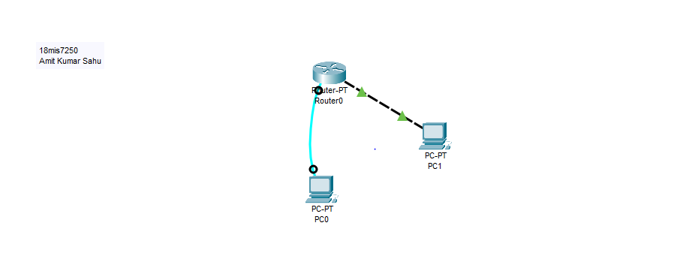

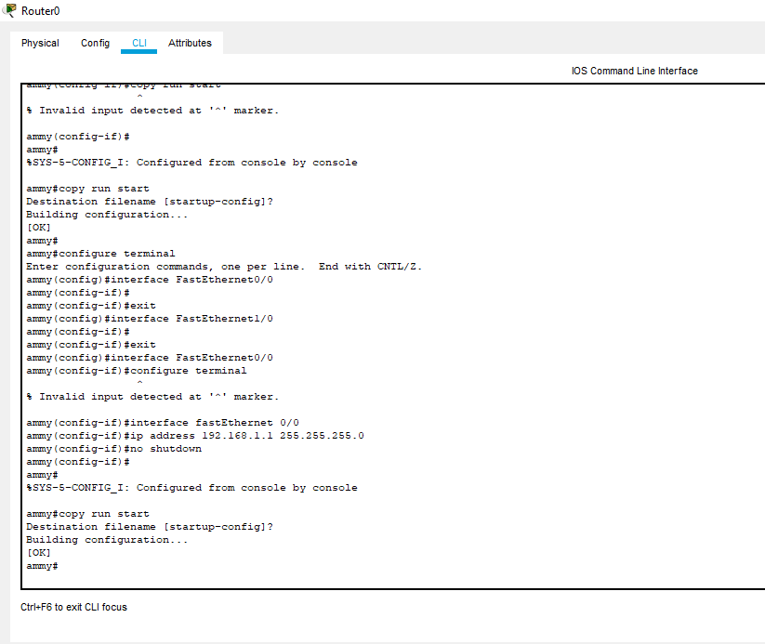

**Able to access computer and router through terminal**

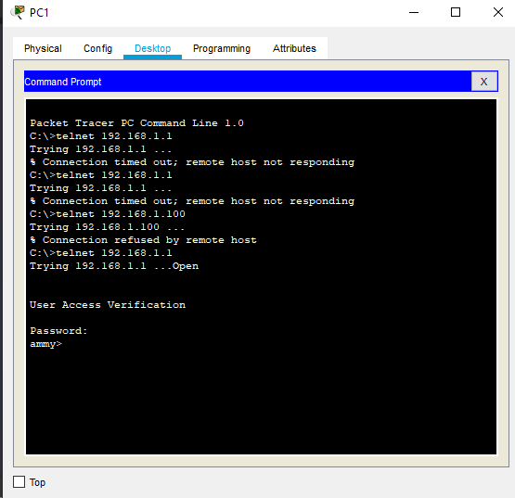

**Adding password**

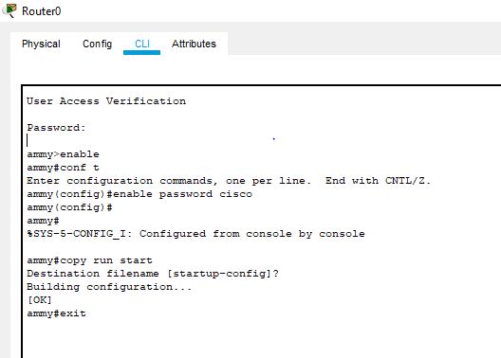

**Configuring password as secret**

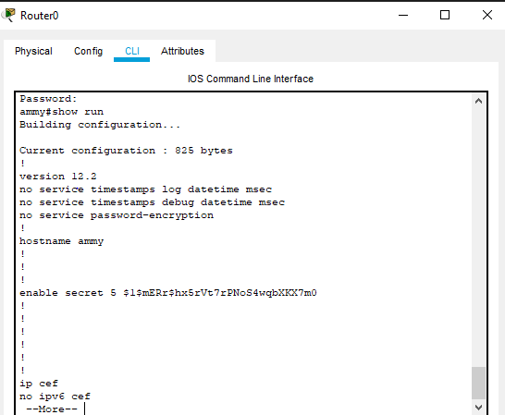

**Configuring Secret Password**

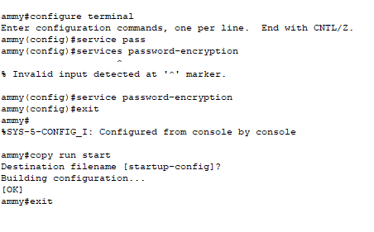

**Adding a message banner when the user logins**

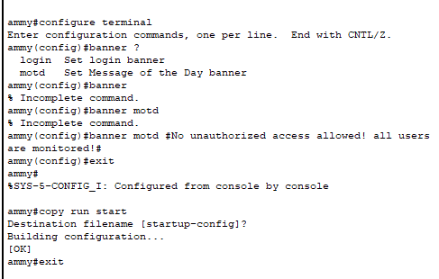

**Output:**

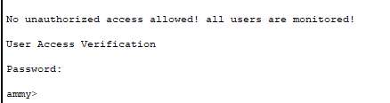

**Configuring switch and pc**

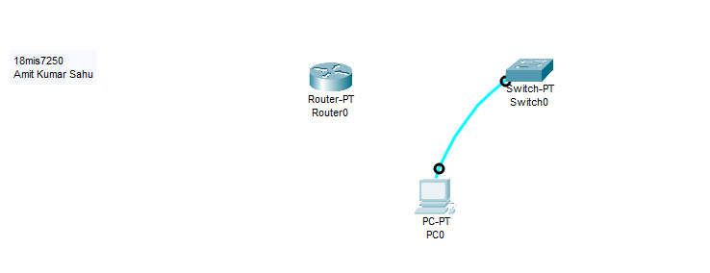

Configuring to access terminal from pc to switch and setting secret password

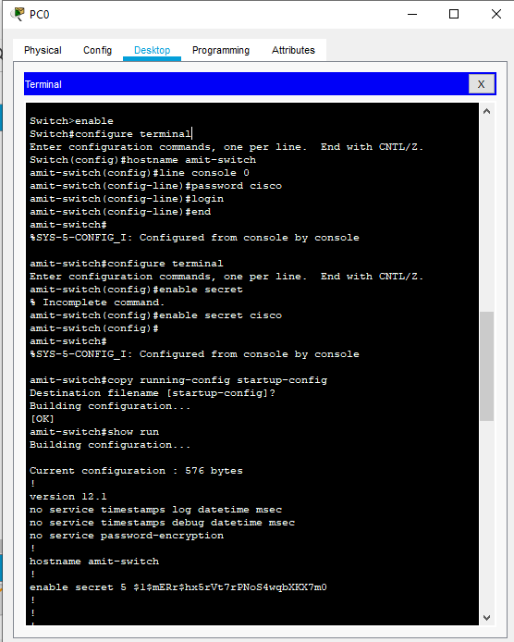

Configured Switch and pc

